Smart Library Request Workflow in ServiceNow
1.Steps to Create Roles
- Open ServiceNow
- Click on All → search for Roles.
- Click on All → search for Roles.
- Select User Administration → Roles.
- Click on New.
- Enter Role Name as librarian → click Submit.
- Again, click on New.
- Enter Role Name as student → click Submit.
- Verify that both roles (librarian and student) are listed in the Roles module.

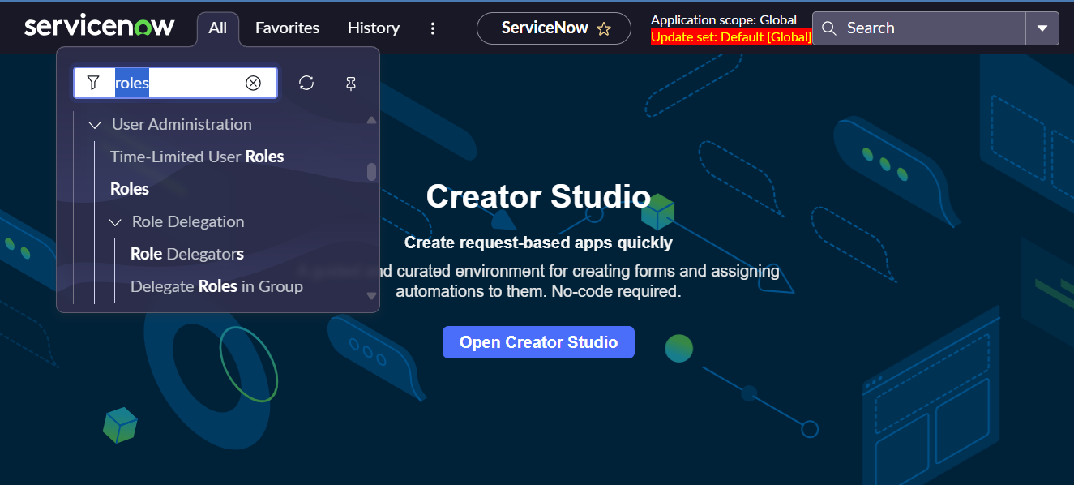
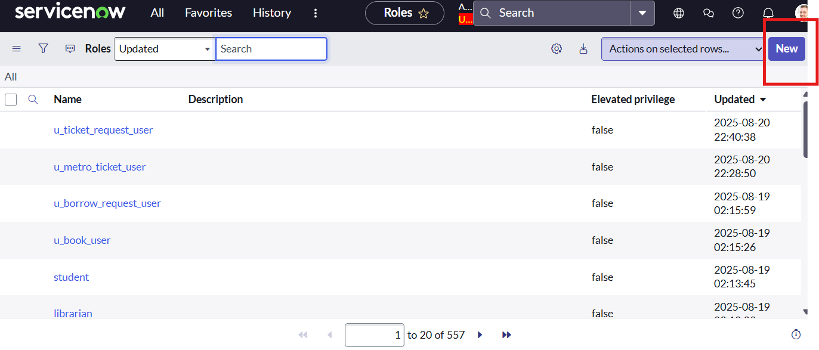

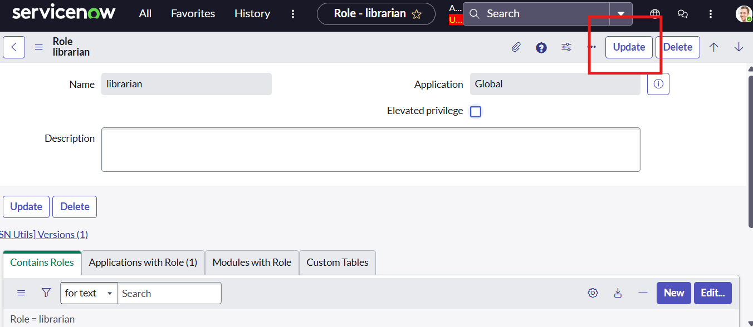

- 2.Steps to Create Tables
- 1.Open ServiceNow.
- Click on All → search for Tables.
- Select System Definition → Tables.
- Click on New.
- Enter Label as Book → click Submit (this creates the table u_book).
- Again, click on New.
- Enter Label as Borrow Request → click Submit (this creates the table u_borrow_request).
- Verify that both tables (Book and Borrow Request) are listed under the Tables module.
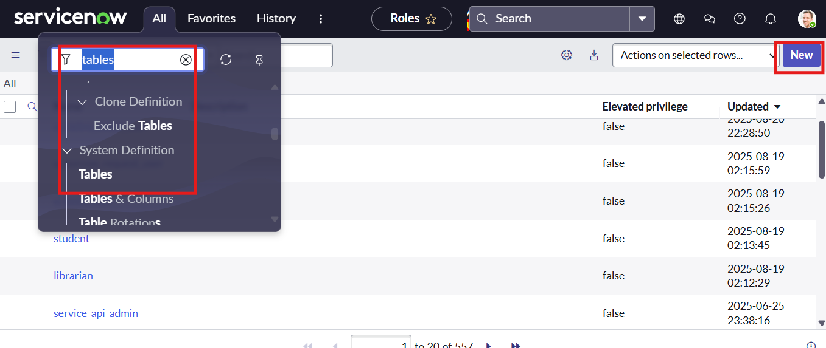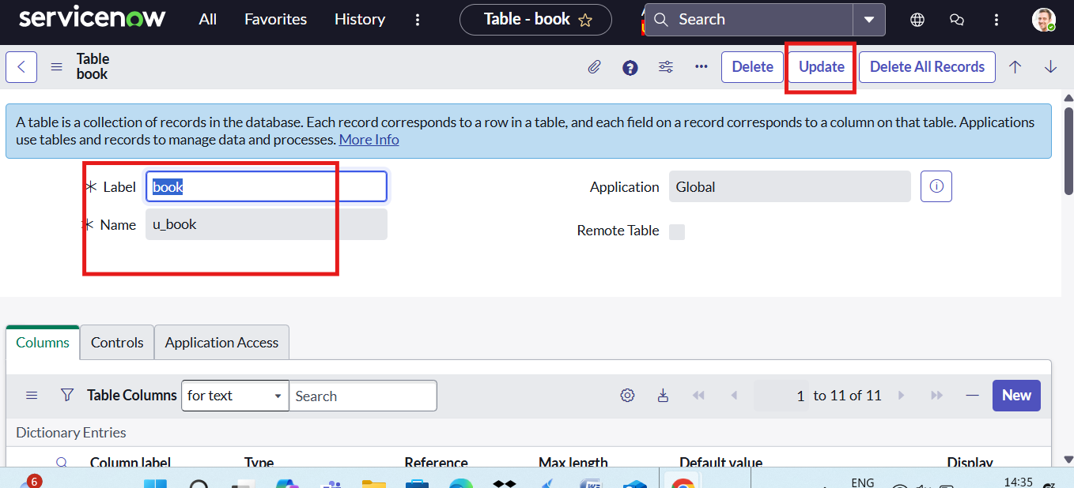

Configuring Table
- Open ServiceNow and click on All in the Application Navigator.
- Search for Tables and select System Definition → Tables.
- From the table list, open Borrow Request [u_borrow_request].
- Scroll down to the Columns (Dictionary) related list.
- Locate and open the field Book (Reference field to Book [u_book]).
- In the field form, switch to Advanced View (click the gear ⚙️ icon if Advanced View is not visible).
- Scroll to the Reference Qualifier section.
- Select Simple as the Reference Qualifier type.
- In the Reference Qualifier Condition, set the condition as: Status is Available.
- Click Update to save the changes.

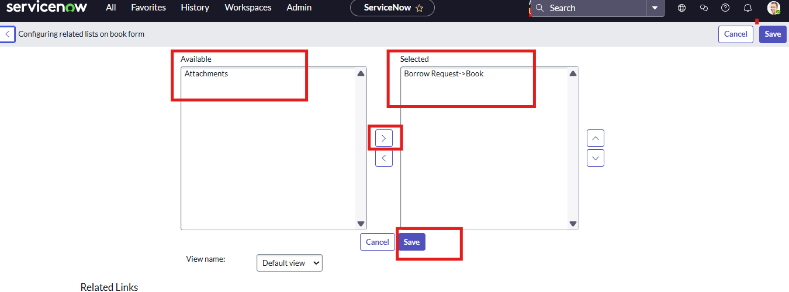

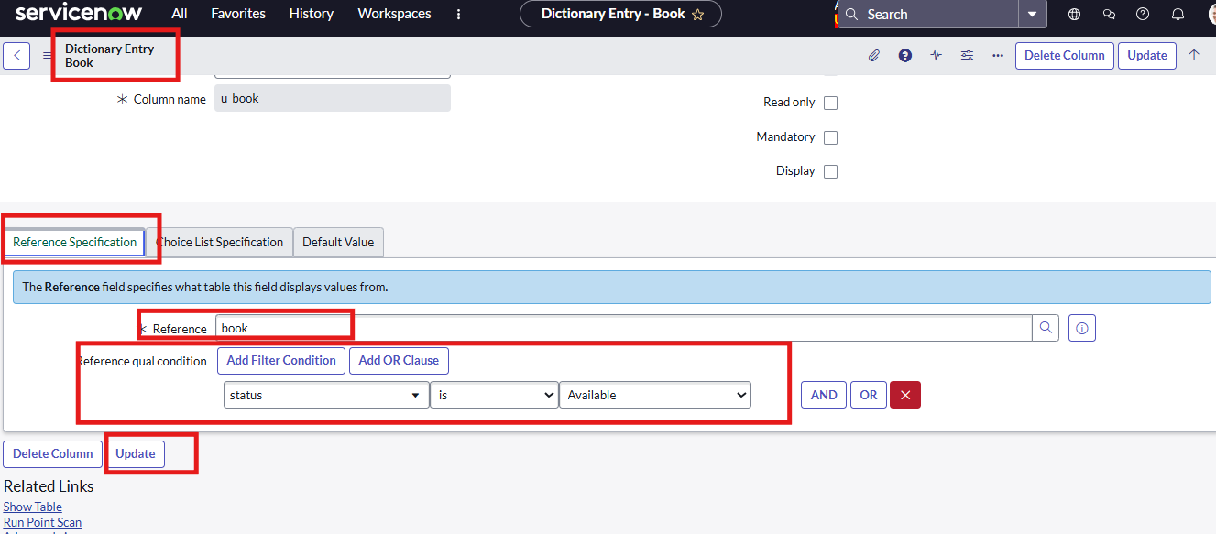

Creating Flow Designer
- Open ServiceNow.
- Click on All → search for Flow Designer.
- Select Flow Designer and click New → Flow.
- Enter Name as Borrow Request Approval Flow → click Submit.
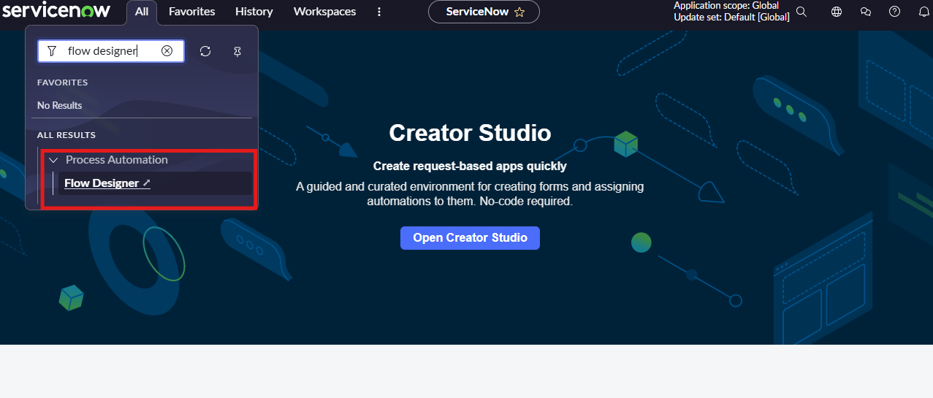

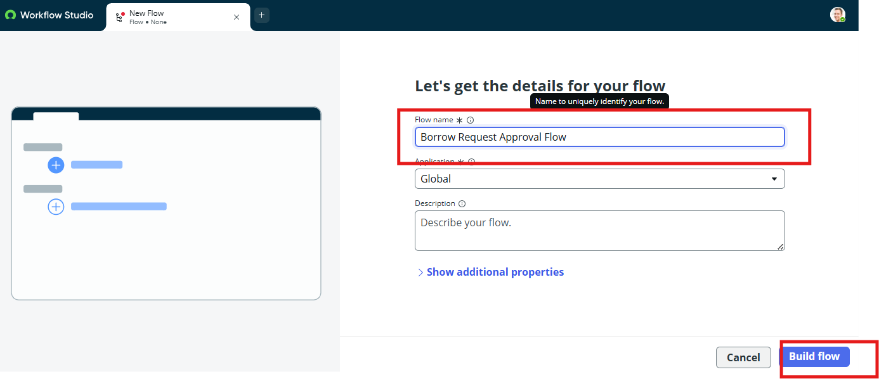
Create UI Policy
- Open ServiceNow.
- Click on All → search for UI Policies.
- Select System UI → UI Policies.
- Click on New.
- Enter Table = Borrow Request [u_borrow_request].
- Enter Short Description = Make Return Date mandatory when Issued.
- Submit the record.
- Reopen the created UI Policy record.
- In the Conditions section, set: Status = Issued.
- In the UI Policy Actions related list, click New.
- Select Field = Return Date.
- Set Mandatory = True.
- Set Visible = True.
- Submit the UI Policy Action.

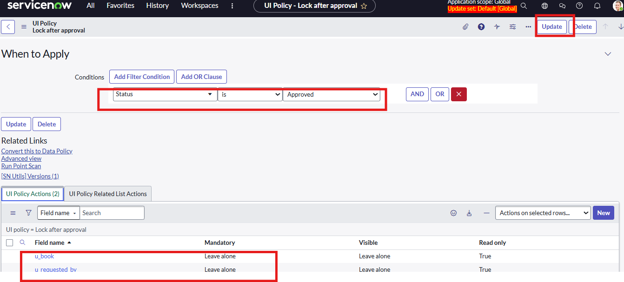
Create Access Control list
- Open ServiceNow.
- Click on All → search for Access Control.
- Select System Security → Access Control (ACL).
- Click New.
- Select Table = Book [u_book].
- Choose Operation = read.
- Set Requires role = student, librarian.

- Submit.
- Again, click New.
- Select Table = Book [u_book].
- Choose Operation = write.
- Set Requires role = librarian
- Again, click New.
- Select Table = Book [u_book].
- Choose Operation = delete.
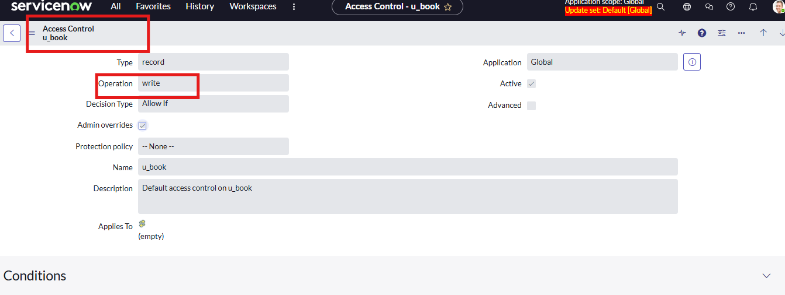

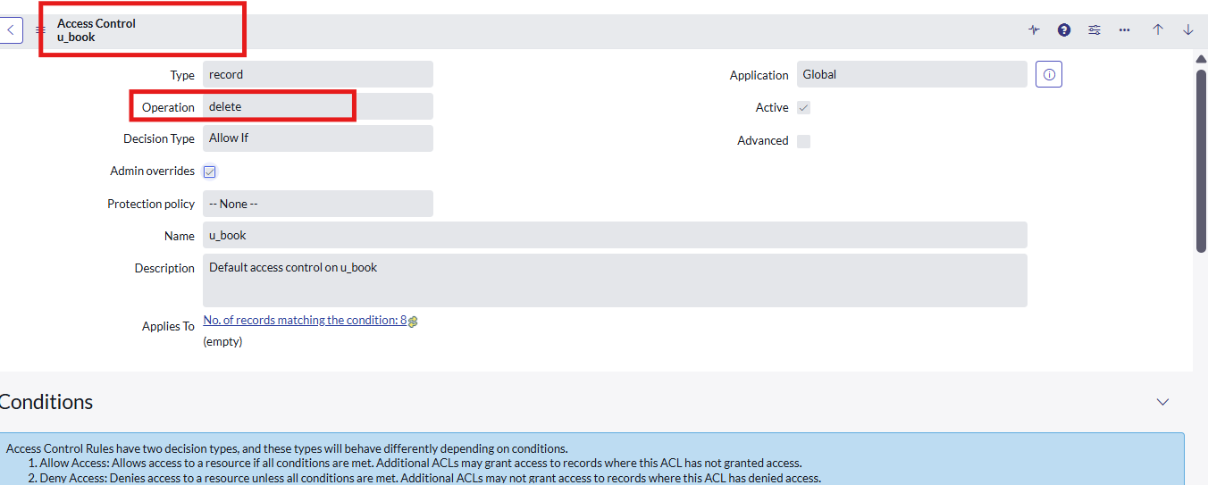

Create Report
- Open ServiceNow.
- Click on All → search for Reports.
- Select Reports → View / Run.
- Click on New.
- Enter Name = Most Borrowed Books.
- Select Source Type = Table.
- Select Table = Borrow Request [u_borrow_request].
- Choose Type = Bar Chart (or Pie Chart as needed).
- In the Group by field, select Book.
- In the Aggregate field, select Count.
- Add a filter: Status = Approved (to count only issued books).
- Click Run to preview the report.
- Adjust chart options (Title, Labels, Legend) as required.
- Click Save. To publish,
- click Sharing → Add roles (student, librarian).
Conclusion
The Library Management Project successfully optimized the process of borrowing and managing books within ServiceNow by implementing structured workflows, role-based access control, and automated approvals. Students can submit borrow requests seamlessly, while librarians can review, validate, and process requests efficiently through controlled access and defined responsibilities.
The system enhances transparency by incorporating request status tracking, automated notifications, and reporting capabilities, ensuring that all stakeholders remain informed throughout the process. Proper validations reduce errors, prevent unauthorized actions, and maintain accurate record management.
Overall, the solution improves operational efficiency, strengthens accountability, and provides a scalable framework that can be extended to support additional academic services such as digital resources, reservation systems, or asset tracking in the future.

